Lab1

Instructions

Edit Instructions
NOTE: While you are required to demonstrate having installed the MySQL software during the lab session, you will also be required to submit a screen shot of the MySQL Welcome screen for the assignment (details to be given during the installation process).

Lab 1 – Part A - Installing the MySQL Development Environment

Due date: DURING THIS LAB CLASS

Instructions for Installing MySQL
- Download Windows installer from MySQL: https://dev.mysql.com/downloads/windows/installer/8.0.html. Make sure to select version the latest version for Windows.
- If you intend on executing the MySQL Installer file while online, download the mysqlinstaller-web-community file.
If you intend on executing the MySQL Installer file while not on online, download the mysql-installer-community file

NOTE: Either selection above is good to use for installation

- Click “No thanks, just start my download” to avoid having to register in Oracle and download the file.
- Run the installer file. (Windows will configure the MySQL Installer - it takes a bit of time).
- If requested, select "Yes" to allow it to make changes to your device and the installation will begin.
- Select the “Custom” setup type and click on Next
  - . Note that WAMP or MAMP or any other server setup from a previous course is not required. If MariaDB is installed on your machine, uninstall it now before continuing.
- Select only the MySQL Server file and the MySQL WorkBench file (you will need to drill down a couple of levels). You can also select the sample databases (if you wish, but it is not necessary). Once you have selected the necessary files, it should look like the screen shot below (with or without the Samples and Examples file). Be aware that the version numbers may not be exactly the same. Select the most recent versions available.
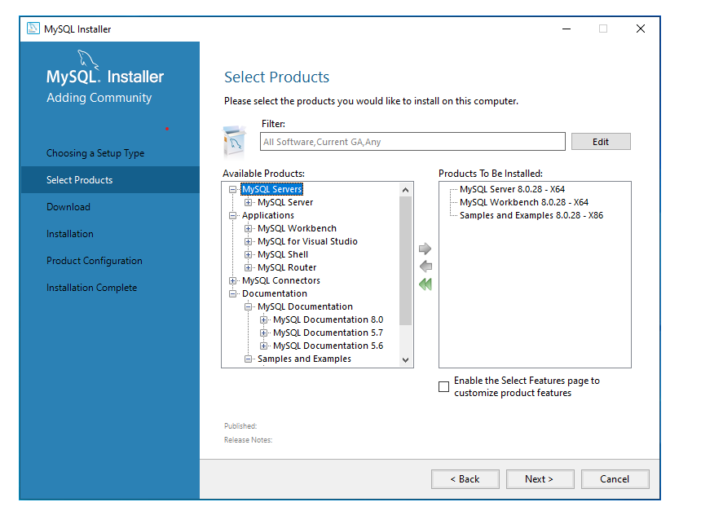
- Click Next.
- Click Execute (All items selected in Step 7 will be installed). Click on Next
- On the Product Configuration screen click on Next.
- Keep the default selection on the next two screens: Type and Networking, Authentication Method (Click on Next twice - one for each screen)
- Create a root password (Keep it simple). Make sure to write your password down because you will need to re-install if you lose it. You do not need to create any users. Click Next
- On the Windows Service screen
  - Change the Windows Service Name to MySQL80-INITIALS (last and first name initials)
  - Make sure that “Start the MySQL Server at System Startup” is checked and click Next.
- On the Service File Permissions screen, simply click on Next
- On the Apply Configuration screen, click on Execute and then click on Finish when completed
- Click Next on the Product Configuration screen.
- Click Finish.
- Launch MySQL Workbench if it is not already running.
- At this step, take a screenshot of the "Welcome to MySQL Workbench" Screen, making sure that the local instance connection with your initials displayed
  - This screenshot will be uploaded into Lab Exercise 1A for grading
  - Either save the screenshot as a png or jpg file
- Click on the default created connection “Local instance MySQL80-INITIALS”. Enter the root password you created in Step 12, if prompted.
- To verify that the database server is running:
  - Select the Administration tab (located approximately mid-way on the object panel on the left (next to the "Schemas" tab)
  - Click on the "Server Status" option (the green "Running" icon should be displayed near the upper-right of the screen)
- Click on the “Home” icon on the top left of the tab bar.
- Click on the Edit>Preferences menu.
- Click the SQL Editor option in the tree of options and uncheck the “Safe Updates” option. (You may need to scroll to the bottom of the screen to see this option.)
- Click on the Modeling>Defaults tree item and make the following changes
  - PK Column Name: id
  - Column Type: VARCHAR(50)
- Click on the Modeling>MySQL tab and make sure the following option is set:
  - Default Storage Engine: InnoDB
- Click on OK
- The installation is now complete

